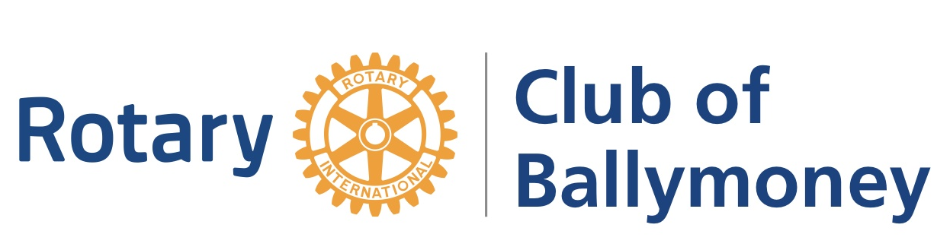
Richard Orr, President
www.ballymoneyrotary.org

Ballymoney Rotary Community “300” Cash Awards
Part B “Application Form” March 2017
The Rotary Club of Ballymoney is seeking to support community based projects that can demonstrate a real benefit to our community and is now inviting applications for 2017.

This is a small grants programme with awards of up to £300, open to groups or organisations based in the former Ballymoney Borough area. The club has allocated £1,500 for this new programme.

Please refer to Part A “Details about the Award” for information about our priorities, eligibility and the application process

Deadline 1pm. Friday 28th. April 2017
Applicants will be notified week beginning 15th. May 2017
Presentation of awards 21st. June 2017

Your organisation & contact details
Name of Organisation or Group
Organisation’s address and contact details Telephone/email/website

What type of organisation or group?  (Please tick) | - Informal voluntary group  - Resident or local community group  - Sports or arts club  - Registered charity  - Community Interest Company  - Other – please state
Charity Registration Number (if applicable)
Please give brief description of the aims & objectives about your organisation. 100 words max.
Name main contact

Position in organisation

Full Address (if different from Organisation’s address
Contact details, telephone, mobile and email address

Name of Organisation’s Bank Account held in
(the name in which a cheque should be written if your application were to be approved)
Your Project / Activity Information
Project title

Details of HOW the award will be used, eg types of activities or service. 200 words max.
Details of WHO the project WILL benefit (community and/or people) 150 words max
Is this a NEW project or is this something you already do? 100 words max.
HOW do you know this project is NEEDED? 100 words max
WHEN will your project or activity start and how long will it run for ? 100 words max
How much are you applying for? | £
Are you seeking funding from any other sources
Budget breakdown summary (Inc. VAT)

Declaration
I confirm that the information provided in this application is correct and that I am

authorised by ……………………………………………………………………… (name of group) to submit to the
Rotary Club of Ballymoney

I further confirm that ……………………………………………………………… (name of group) agree, if successful, to attend the Rotary Club Award Presentation on 21st. June, to use the Rotary logo on publicity about this work and to provide a feedback/impact report when the funded activity has taken place.

Please check that you have answered all the questions and included:
- Your most recent accounts/financial statement or bank statement
- A copy of your constitution / governing document
Failure to enclose either or both these documents would disqualify the application

Signed

Date

Application Process
- Interested groups/organisations should complete Part B “Application Form” and return by 1 pm, Friday 28th. April 2017.
- Applications will be accepted by email ballymoneyrotary@gmail.com. If you wish to submit a hard copy, please return to Ballymoney Communities Resource Centre.

Ballymoney Communities Resource Centre (BCRC)
Units 22-23 Acorn Business Centre
2 Riada Avenue
Ballymoney
BT53 7LH
info@theresourcecentre.org
028 2766 5068

- Please do not enclose any additional paperwork – we will contact you if any other documents are required.
- If you have any queries about this programme or completing the application form, please email ballymoneyrotary@gmail.com or speak to staff at BCRC.

